TRETMAN SA DENTALNIM IMPLANTATIMA U PACIENATA SA HIPODONCIOM

Sazetak

Hipodoncija u stalnoj denticiji pretsavlja izuzetan klinicki izazov, posebno kada je u pitanju lecenje adolescentnih pacienata kod kojih postoji nedostatak frontalnih zuba. Oni imaju ozbiljne estetske i psiholoske poremecaje i zadovoljivanje estetskog momenta kod adolescenata je glavna motivacijja lecenja, ali i cilj u upravljanu terapeuta za poboljsanje estetike kod hipodoncije i prirodno obnavljanje mastikatornih funkcija za dugim i predvidljivim rezultatima. Izbor terapije zahteva timski rad koordinacionog modela, pravilni plan terapije, zatim odredzivanje najpogodnijeg vremena i nacina izvodzenja terapije i konacno sprovodzenje ortodontske, oralnohirurske i restavrativne terapije. Kroz prezentaciju klinickog materijala, u slucaju hipodoncija lateralnih inciziva u maksili i mandibuli, prikaziva se multidisciplinarni prstup u terapiji sa dentalnim implantatima i postizanje maksimalnih rezultata sa estetske i funkcionalne tacke gledista. Ovaj kompleks lecenja, zbog dugog perioda sa ortodontskog i hirurskog aspekta, izaziva i dobru komunikaciju sa pacientima i njegovim roditeljima ili njegove uze porodice.

Kljucne reci: hipodoncija, dentalni implantati, oralnohirurski aspekti, ortodontska terapija

TREATMENT OPTION WITH DENTAL IMPLANTS IN PATIENTS WITH HYPODONTIA

Abstract

Hypodontia in the permanent dentition is a significant clinical challenge, particularly in the treatment of adolescent patients who are missing anterior teeth. They have severe aesthetic and psychological disorders and satisfying the aesthetic moment is the main motivation for treatment, but the goal in the management of hypodontia for the therapist is not only to improve the aesthetics but also to accomplish a good masticatory function with long lasting and predictable results.
The selection of an appropriate therapeutic option, needs multidisciplinary approach and team coordination, first during treatment planning and then for determining the most appropriate time and method for subsequent orthodontic, surgical and prosthetic treatment.
The aim of the authors is through the presentation of clinical material with hypodontia of the lateral incisors in maxilla and mandible, to show the need of multidisciplinary approach in the treatment of hypodontia using dental implants in the aesthetic region, and to emphasize the critical moments of the surgical aspects in order to achieve the best aesthetic and functional outcome.
Good cooperation with the patients and their family is of particular importance, especially because of the long interval of orthodontic and surgical treatment until the final results are achieved.

Key words: hypodontia, dental implants, surgical aspects, orthodontic therapy

Introduction
Hypodontia with prevalence in the permanent dentition to range from 2.3% to 11.3%, depending on the population investigated or 4.6−6.3% within the dentition of white European populations, is the most common developmental anomaly in humans. Hypodontia is most frequently used term, but many other terms appear in the literature to describe a reduction in number of teeth: aplasia, congenitally missing teeth, absence of teeth, agenesis of teeth, lack of teeth, oligodontia or anodontia. These condition frequently involve the last teeth of a class to develop (I2, P2, M3) suggesting a possible link with evolutionary trends. Hypodontia can either occur as an isolated condition (non-syndromichypodontia) involving one (80% of cases), a few (less than 10%) or many teeth (less than 1%), or can be associated with a systemic condition or syndrome (syndromichypodontia), associated with more than 49 syndromes, as ectodermal displasia, Down ̓s syndrome, cleft lip and palate, hemifacialmicrosomia etc. The cause of isolated missing teeth remains unclear, but the condition is believed to be associated with genetic or environmental factors during dental development. Etiology due to hormonal defects are idiopathic hypoparathyroidism and pseudohypoparathyroidism. Environmental causes involving exposure to PCBs (ex.dioxin) radiation (1) anticancer chemotherapeutic agents allergy and toxic epidermal necrolysis after drug usage. Most authors report a small but not significant predominance of hypodontia in females. According to Nunn et all (2), congenital absence of teeth is a consequence of: physical obstruction or disruption of the dental lamina, space limitation, functional abnormalities of the dental epithelium and failure of initiation of the underlying mesenchyme.
Clinical examination together with panoramic x-ray in detecting or confirming dental development is crucial . Because all permanent tooth crowns mineralized by the age of six, except the third molars, diagnosis of tooth agenesis in the permanent dentition should be made after this age. The importance of an accurate diagnosis and an effective treatment plan with appropriate coordination of timing of interventions should involve a mutidisciplinary team approach with participation of pedodontist, orthodontist, oral and maxillofacial surgeon andprosthodontist. However, hypodontia presents challenges for the clinician with variety of treatment options, depends upon the severity of the case.
In the treatment concept, there are many alternatives: prosthodontics therapy in simple cases, orthodontic space closure (spontaneous or with conventional orthodontic modalities), orthodontic space redistribution or space opening for prosthetic replacements or rehabilitation with dental implants or autotransplantation (3). Dental implants are a predictable and successful means of replacing missing teeth by supporting crowns, bridges, overdentures and other prostheses.
This paper will present some of our clinical cases, to illustrate a therapeutical approach with dental implants to replace congenitally missing lateral incisors in the upper and in the lower jaw.
Case report no. 1
Male, aged 19 years and 6 months, was reported for dentaltreatment to the University Dental Clinical Centar"St.Pantelejmon" in Skopje, Macedonia. His general medical history was not significant, with family history of hypodontia in one parent. Oral hygiene and gingival status were good and no caries was found.
Radiographic examination confirmed clinical absence and developmentally missing of both lateral incisor in the lower jaw-hypodontia of 32 and 42, with persistent deciduous tooth on the right side (Fig. 1a,1b), and space closed in the left side.
Preoperative models were mounted and analyzed (Figures 2a,2b). Our therapeutically plan was orthodontic treatment in the beginning, for redistribution the space and correction of deep byte and as final, rehabilitation with dental implants. The patient refuses the orthodontic treatment with request for dental implanton the right side, as soon as possible to improve the aesthetic moment.
After correction of the byte with restorations on the occlusal side of the molars, the immediate implant placement with extraction of deciduous tooth was performed.
Intraoperative view: Traumatic occlusion made resorption of the vestibular lamina on the central permanent incisor and the lateral deciduous tooth,this indicates augmentation procedure together with immediate placement of implant. (Figures 3a, 3b). After preparation of the implant bed, we insert Ankylos® CX implant, 14 mm long with 3,5 mm diameter, from DentsplyFriadent, with application of the xenogenic bone supstitute materials - BiO-Oss®spongiosa granules, GeistlichBiomaterials. (Figures 4a,4b). Provisional crown was made immediately after implantation without occlusal contact. (Figure 5). A postoperative radiograph was taken to verify proper implant placement and to assess the relationship of the implant to surrounding structures. The patient was instructed to rinse with chlorhexidine for 60 seconds twice a day for 2 weeks
An antibiotic regimen of amoxicillin 1 000 mg, was prescribed to be taken an hour before implant surgery and for the next 5 days.
After 4 mounths an abutment was placed and after a few years a control radiograph was taken (Figures 6a, 6b, 7).

Case report no. 2
A 20-year-old female patient with no medical contradictions presented for replacement of the maxillary lateral incisors (Figure 1). An outside orthodontic specialist completed treatment 6 months previously and the adjacent teeth were in ideal position. Patient wears a removable retainer which also restores UR2 UL2. There was 7.0 mm between the central incisor and cuspid. The problem in this patient was the hard and soft-tissue loss, especially reduction of the vestibular alveolar bone, obvious in clinical examination and on x-ray (Figures 2a,2b).
The advanced resorption of the alveolar bone is a problem for implant placement with limitations of drilling into an atrophic ridge. There are several methods to enhance the bone volume depends of the severity of resorption, like bone condensing and bone spreading technique witch are recommended in soft bone like it is in maxilla. Both techniques were performed to enhance and condense the bone in maxilla and we did not use bone graft material.(Figures 3).
Ankylos CX Implants A11 (Dentsply®,Friadent), were selected to replace the lateral incisors. The implants were inserted 0.5 mm in subcrestal position for maximum esthetic results (Figures4a, 4b).
The X-ray after 4 mounths (Figure 5), shows ideal implant positions without any bone resorption around them, and we perform the final prosthetic restavration using zirconia abatments and
crowns (Figure 6).
Discussion
The range of problems that can appear in patients with hypodontia is enormous and each case should be discussed with a multidisciplinary team. Patients and parents’concerns, needs, and attitude towards various treatment options should be taken into full consideration when formulating a treatment plan. In some cases conventional crown and bridge treatment offers many advantages as a therapeutic choice for tooth replacement - the treatment time is considerably shorter when compared to implant-based treatment. This approach can also be comparatively cost-effective with excellent aesthetic results. The disadvantage is the preparation of unaffected teeth which invites a multitude of future periodontal and endodontic problems. Orthodontic space closure or space redistribution is usually a necessary treatment modality for missing maxillary lateral incisors. The most obvious advantage of this approach is the elimination of the need for a lifelong maintenance of a fixed restoration as well as the consequences of preparing unrestored teeth. Other advantages include the permanent nature of a completed treatment and the avoidance of interim provisional partial dentures. However, with the completion of this treatment there is a tendency for the space between the anterior teeth to reopen. The major disadvantage of this treatment relates to the positioning of the maxillary cuspid tooth in the lateral incisor position, as well as the shape and color difference among maxillary cuspids, maxillary central incisors, and mandibular incisors.
Dental implants have revolutionized the restoration of edentulous and partially edentulous patients, including individuals who are congenitally missing maxillary or mandibular lateral incisors. The advantages of this treatment option include longevity, preservation of adjacent teeth, aesthetics, but implant therapy may take 4-6 months to place and prosthetic restore the implant. Another disadvantages of implant therapy is a possibility of implant failure after periimplantitis, which often results in bone loss, bone grafting and retreatment with significant cost.
Despite the short comings of implant therapy, it has emerged as a conservative and predictable method for replacing missing congenital lateral incisors.
The condition of congenitally missing teeth is usually diagnosed in childhood, but implant placement has to be postponed until the completion of skeletal growth and soft tissue complex. When the orthodontic treatment is finished and the patients have reached the age of 18, they are rescheduled at a subsequent treatment. In young persons, proper timing of implant placement is important. There is a danger in placing implants too early in development, because implants are not capable of compensatory eruption and behave like ankylosed teeth. There is general agreement that implant placement should be delayed until after puberty, when growth and skeletal development are complete. During the interim period, preservation of alveolar bone volume is important, which means that the hypodontia requires a coordinated plan of therapy and an appropriate amount of time for the specialistic treatment.
The timing of the extraction of retained primary teeth is also critical for the final result. Usually it is better to delay the removal of retained primary teeth to maintain the surrounding dentoalveolar bone, if the plan is rehabilitation with dental implants. Of particular importance is the preliminary detailed planning and detailed analysis of the jaws and natural teeth which are present. It is important that there is sufficient space to place the implants with adequate bone quality and quantity to provide good anchorage. The quantity and morphology of the bone have to be assessed preoperatively in all dimension using clinical and radiology examinations. Sometimes, when the bone volume is insufficient, it may be necessary to consider augmenting the jaw with autologous bone or with bone graft materials, before implant placement or in the time of implantation procedure. An implant is of no use if it cannot be restored successfully, and thus the planning includes a careful check on the type of prostheses which may be used.
In longitudinal studies, conventional implant treatment has a success rate of 91 to 99% in the mandible and 84 to 92% in the maxilla. Worsaae N at al (4) observed 112 patients suffering from oligodontia for a period of 5 years. Ten of the patients (8.9%) suffered from ectodermal dysplasia. The total number of missing teeth was 1126, with an average of 10 per patient. Fixed implant-supported prosthetic restoration was used in 90% to replace missing teeth, often combined with alveolar ridge augmentations (73%), sinus floor augmentation (43%), inferior alveolar nerve transposition (18%) and orthognathic surgery (27%). Finnema et al (5) reported implant survival rates of 86% and 96% for the mandible and maxilla, after a observation period of 3 years in 13 patients with a total of 87 implants. Créton et al (6), reported of 89.8% survival rate in a 5-year period of evaluationon the 214 placed implantsin patients with severe hypodontia, which is acceptable, regarding compromised anatomic situation and the complexity of treatment. Durstberger et al (7) observed an implant survival rate of 96% after 5 years in 13 patients and 69 implants.
In recent years, several studies on immediate loading of implants have demonstrated that it is possible to achieve success comparable to the classic 2-stage approach. Hahn et al (8) reported a survival rate of 95.7% of immediate loading of implants placed in the aesthetic zone. All studies recommended maximization of implant stability by using longer implants and eliminating occlusal contact in centric and excursive movements.
Also, there are contraindications to implant treatment for replacement of congenitally missing lateral incisors, like malposition roots of the proximal teeth. This often requires orthodontic treatment before implant placement, or smaller-diameter of the dental implants.

Conclusion
Successful outcomes in the management of patients with hypodontia depend on careful diagnosis and treatment planning, which requires cooperation between specialists in different disciplines.
There are several treatment modalities available to replace missing lateral incisors and each of them has advantages and disadvantages, that should be considered with patients and parents especially because the treatment duration for patients with hypodontia may extend over many years. Dental implants are a predictable and successful treatment option for replacing missing congenital lateral incisors and although a number of therapeutic alternatives should be considered, treatment with implants allows the clinician to avoid the preparation of adjacent teeth and provides long-term solution to the clinical problem.

References:
- Kaste SC, Goodman P, Leisenring W (2009) Impact of radiation and chemotherapy on risk of dental abnormalities: a report from the Childhood Cancer Survivor Study. Cancer; 115 (24): 5817–27
- Nunn JH, Carter NE, Gillgrass TJ, Hobson RS, Jepson NJ, Meechan JG, Nohl FS (2003) The interdisciplinary management of hypodontia: background and role of paediatric dentistry Br Dent J 194, 245 - 251
- Kristenson L, Lagerström L (1991) Autotransplantation of teeth in cases with agenesis or traumatic loss of maxillary incisors. Eur J Orthod; 13: 486–492
- Worsaae, N. B. N. Jensen, B. Holm, J. Holsko (2007) Treatment of severe hypodontia–oligodontia—an interdisciplinary concept. Int. J. Oral Maxillofac. Surg.; 36: 473–480
- Finnema KJ, Raghoebar GM, et al, (2005) Oral rehabilitation with dental implants in oligodontia patients. Int J Prosthodont 18:203-9,.
- Créton et al. (2010) Implant Treatment and Severe Hypodontia. J Oral Maxillofac Surg 68:530-538,.
- Durstberger G, Celar A, Watzek G. (1999) Implant-surgical and prosthetic rehabilitationof patients with multiple dentalaplasia: a clinical report. Int J Oral Maxillofac. Implants: 14: 417–423.
- Hahn J. (2000) Single-stage, immediate loading, and flapless surgery. J Oral Implantol.;26:193-198.
Figures 1a,1b. Clinical view and x-ray examination
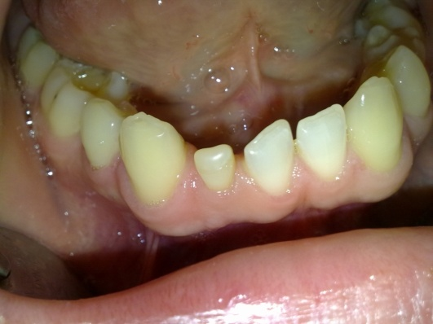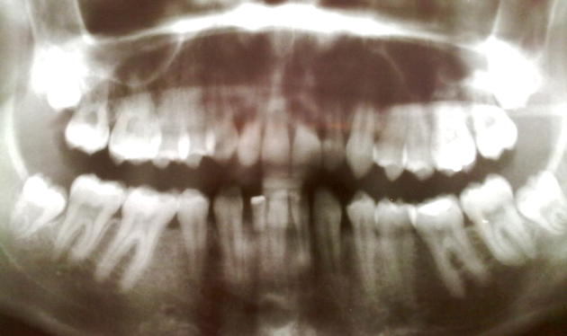Figures 2a, 2b. Analyses of the studio model

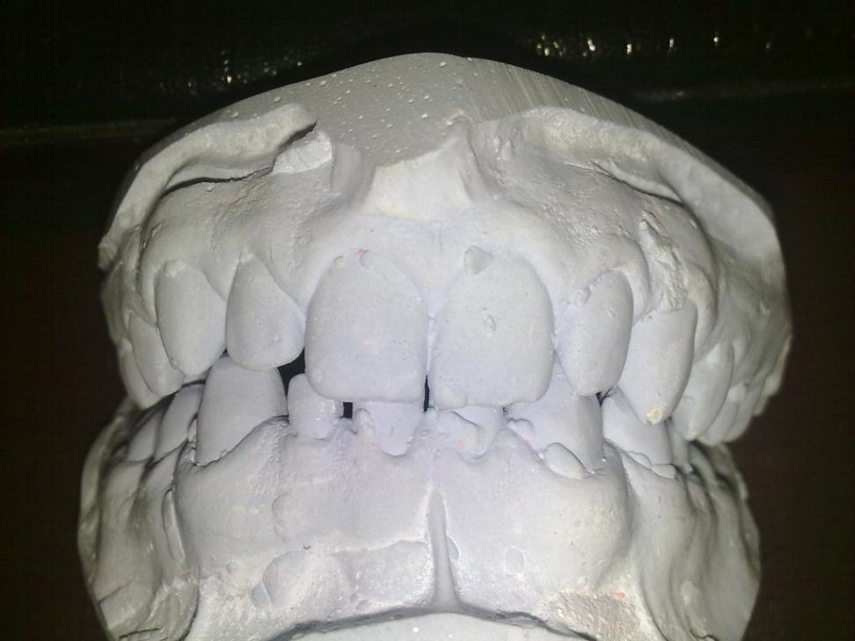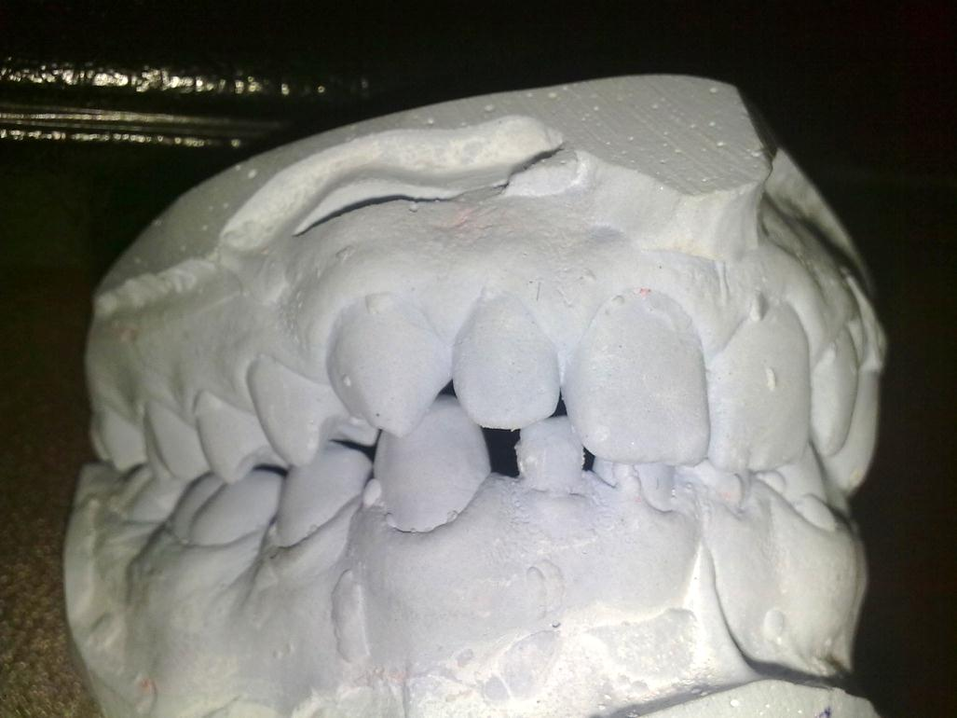Figures (3a, 3b). Sufficient mesio-distal space. Resorption of the bone on the central permanent incisor and the lateral deciduous tooth and resorption of the root of the lateral deciduous tooth
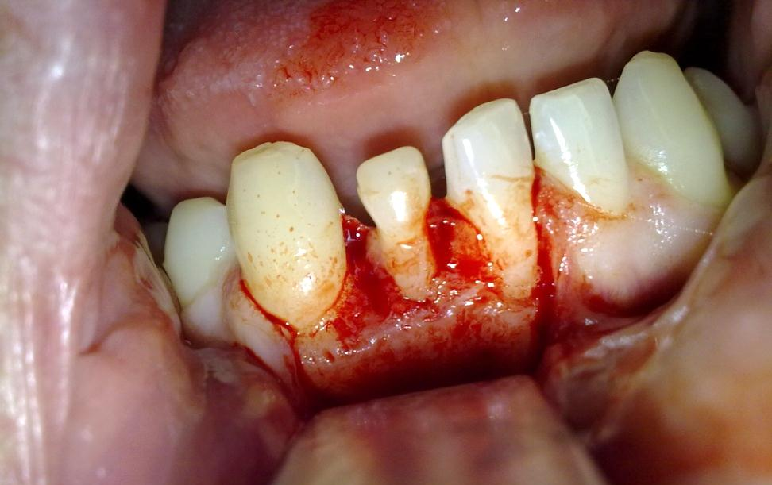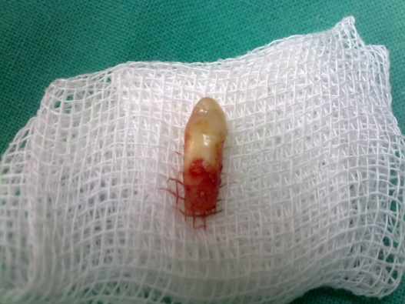

Figures (4a, 4b). Implant insertion and application of bone graft materials

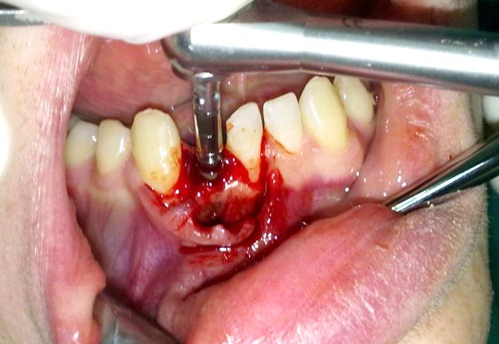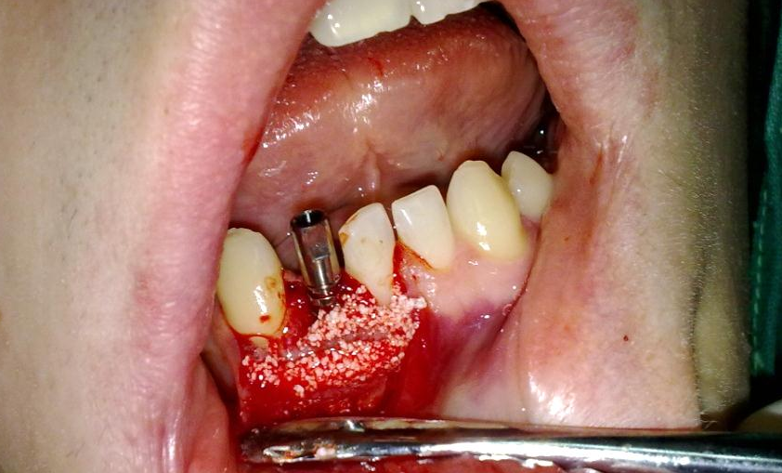
Figure(5). Temporary crown immediately after surgery

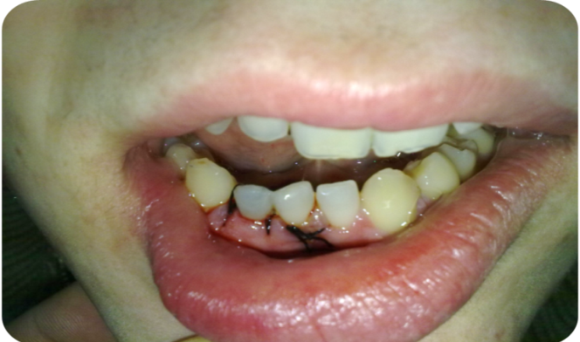

Figures(6a, 6b). Intraoral view after 4 mounths without and with abutment

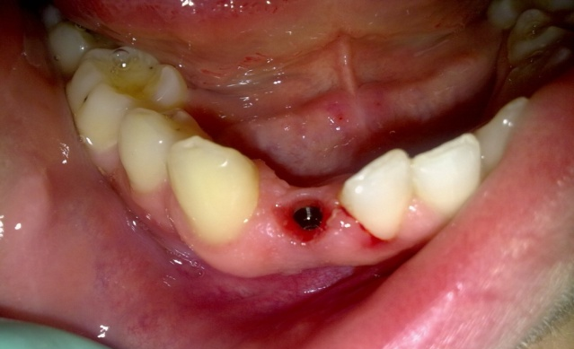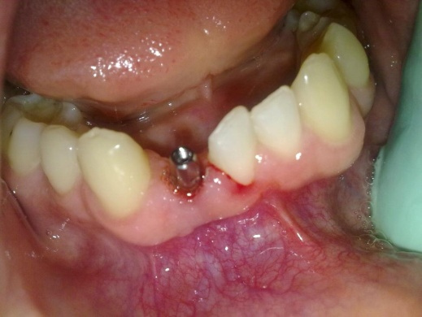

Figure 7. X-ray after 3 years.

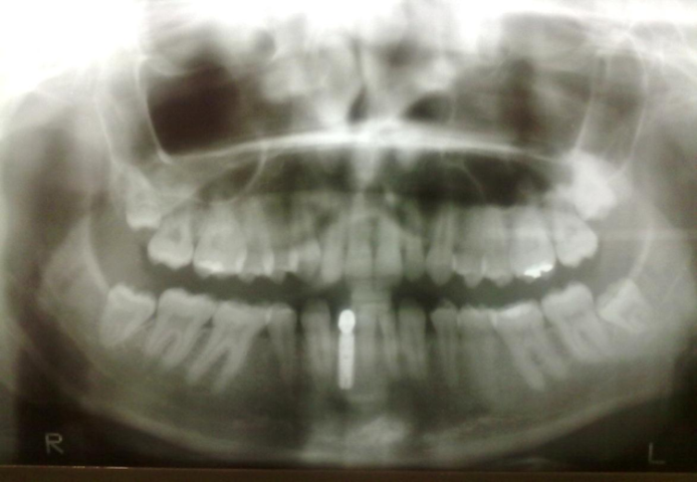
Case No.2
Figure 1. Hypodontia of the UR2 UL2.
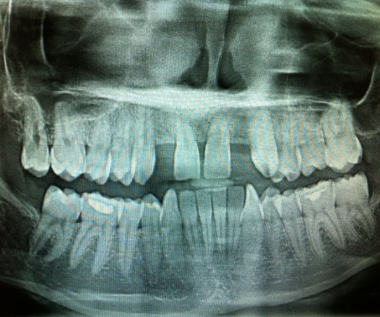

Figures (2a,2b). Hard and soft-tissue loss, especially reduction of the buccal alveolar bone

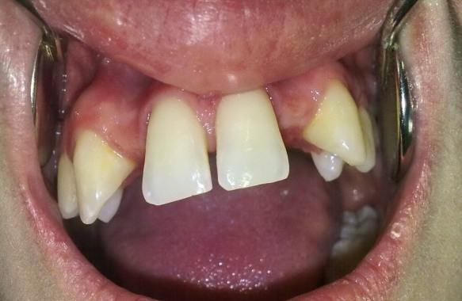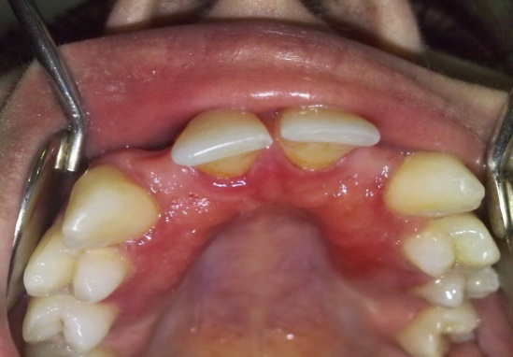

Figure 3a. Bone spreading technique (BST) and bone condensing for enhance of the bone volume

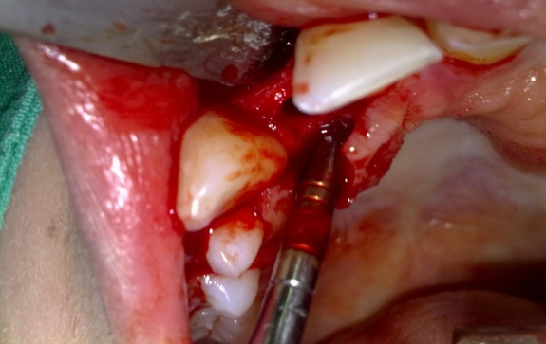
Figure 3b.Testing the position and angulation of the implant bed
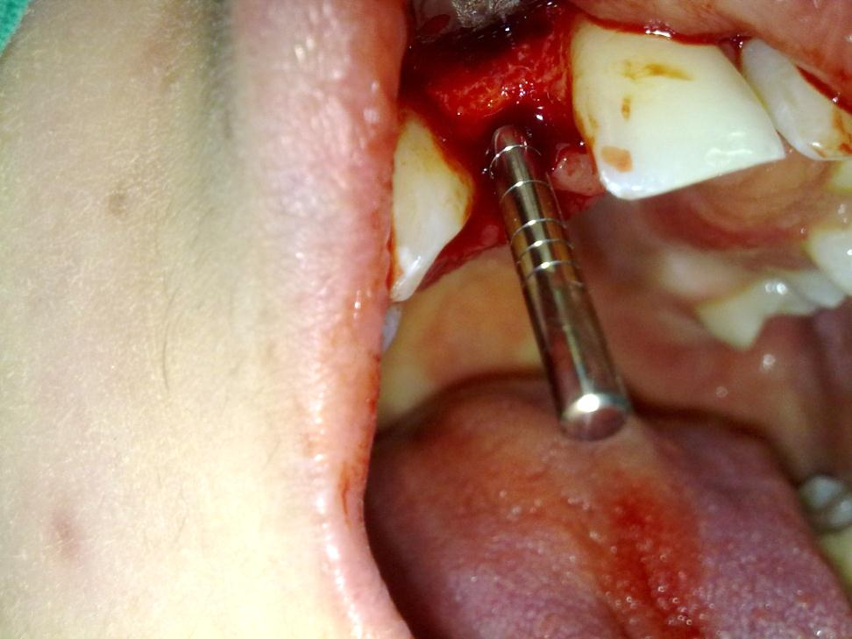
Figures (4a, 4b). Implant placement and final subcortical position of the implant for maximum esthetic results.
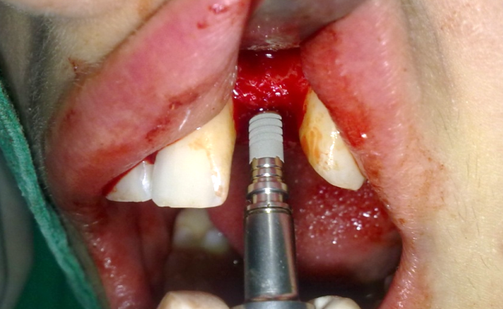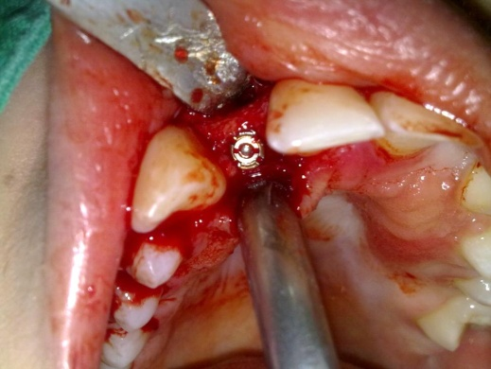

Figure 5. X-ray after 4 mounths

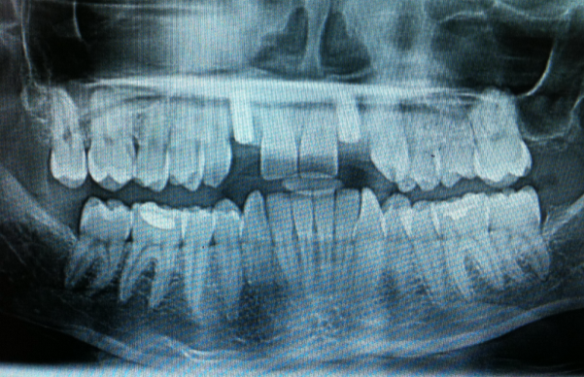
Figure 6. Final prosthetic restavration

